**Sonar Integration with Jenkins: (For Maven Projects)**

**Plugins Installation in Jenkins:**

To install plugins in Jenkins, follow the following steps:

1. Login to Jenkins with administrator account.
2. Click on **Manage Jenkins Tab**

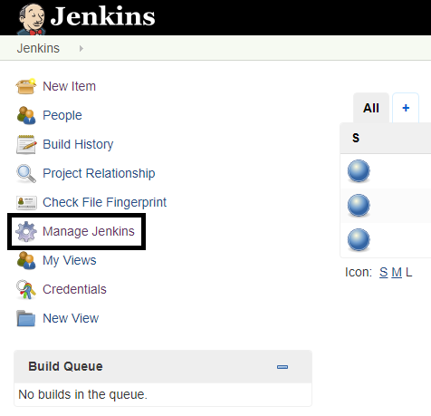

1. Now click on **Manage Plugins Tab**

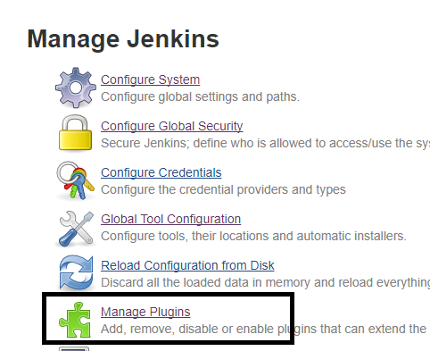

1. Now click on **Available Tab**.

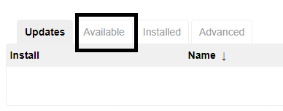

1. Search for required Plugins in the search box



1. Beside your required plugin, you will find a checkbox to install it. Click on check box.



1. After selecting the plugin click on any of the one buttons i.e., **Install without restart** or **Download now and install after restart**. If choose **Download now and install after restart**, you need to restart the Jenkins server to apply the changes.



**Required Plugins:**

1. Maven Integration Plugin
2. SonarQube Scanner for Jenkins
3. JaCoCo Plugin

**Project Creation and Build In Jenkins:**

1. Click on New Item link

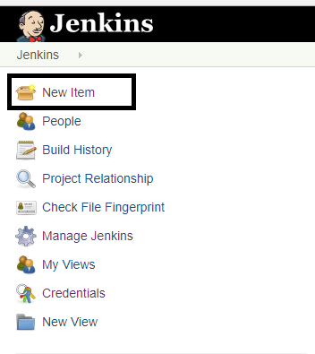

1. Provide a **name** for the project and choose it as a **Maven Project** then click on **OK Button.**

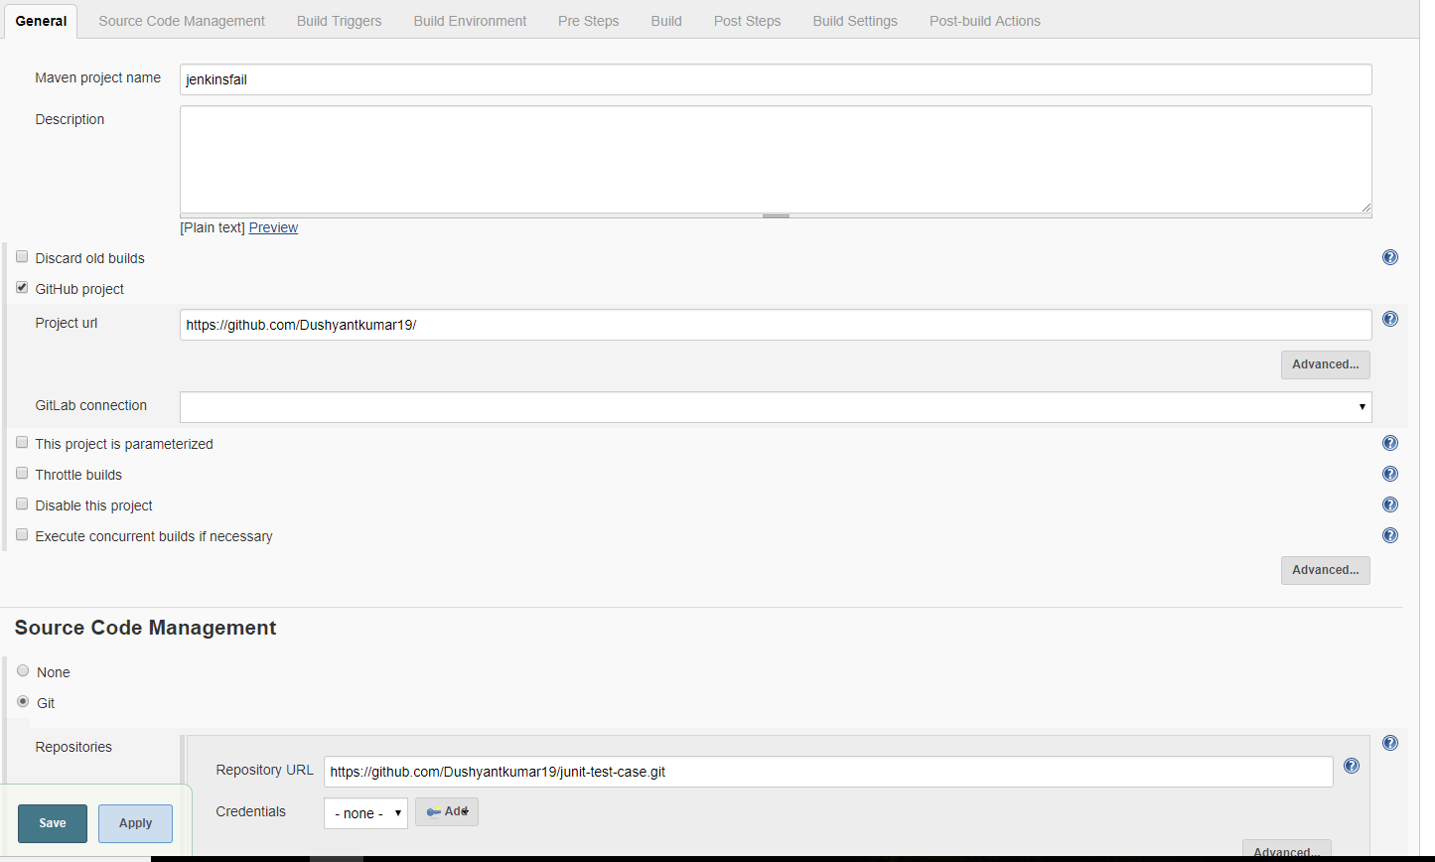

1. Now a Configuration window will appear
2. In the Source Management Tab choose GIT and provide your Repository URL as well as your credentials.

Set the branch on which you want to work.

If needed increase the **Timeout (in minutes) for checkout operation and Timeout (in minutes) for clone and fetch operations in the Advance behaviors options**.

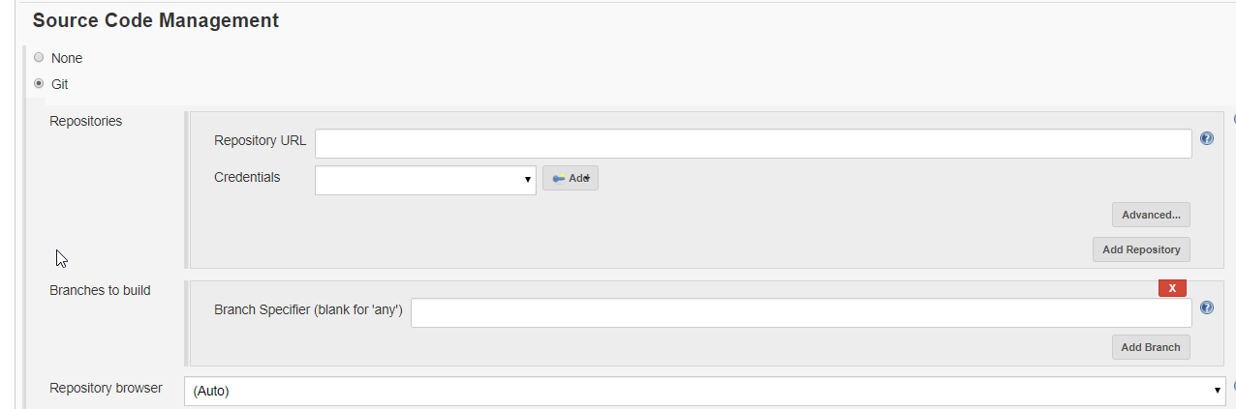

1. Choose as shown in the image

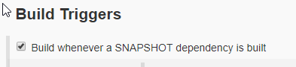

1. Choose the **build environment** as shown below

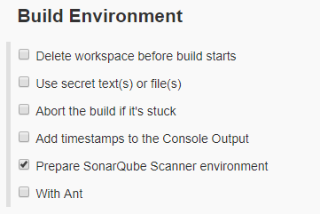

1. Specify the **maven goals** as shown below.

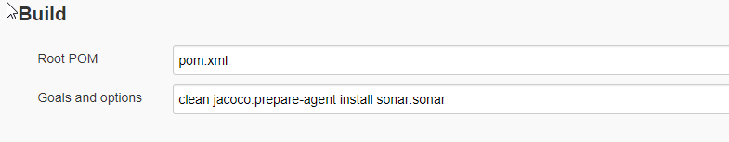

1. Click on **save** button.

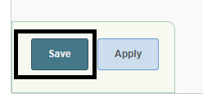

**Configure Sonar and Maven Properties in Jenkins:**

1. Click on **Manage Jenkins Tab**



1. Click on **Configure System**

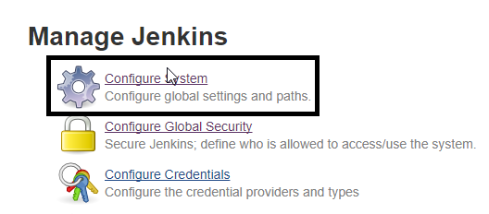

1. Set **Maven Environment Variables**

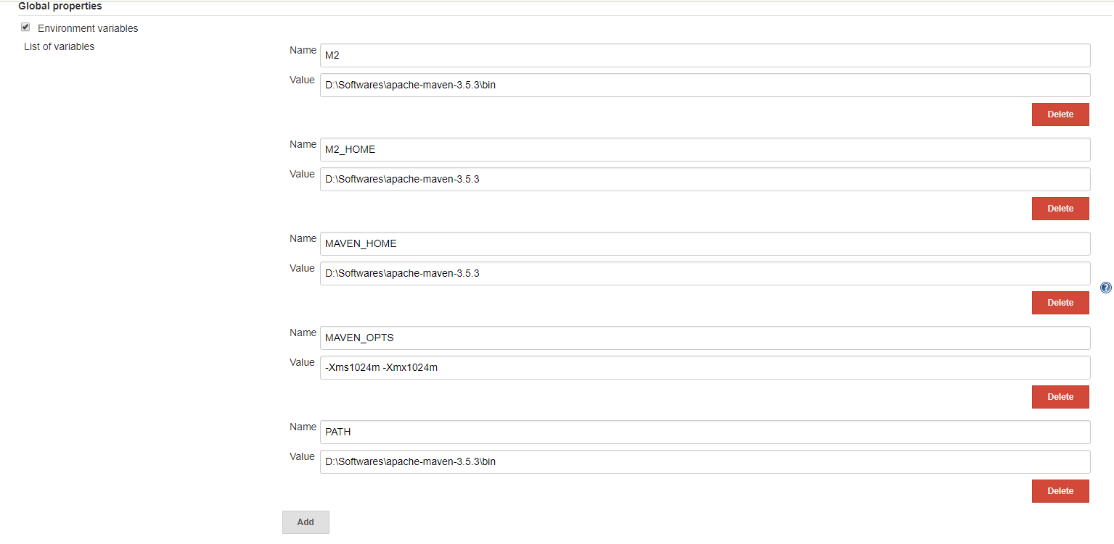

1. Set **SonarQube server** details.

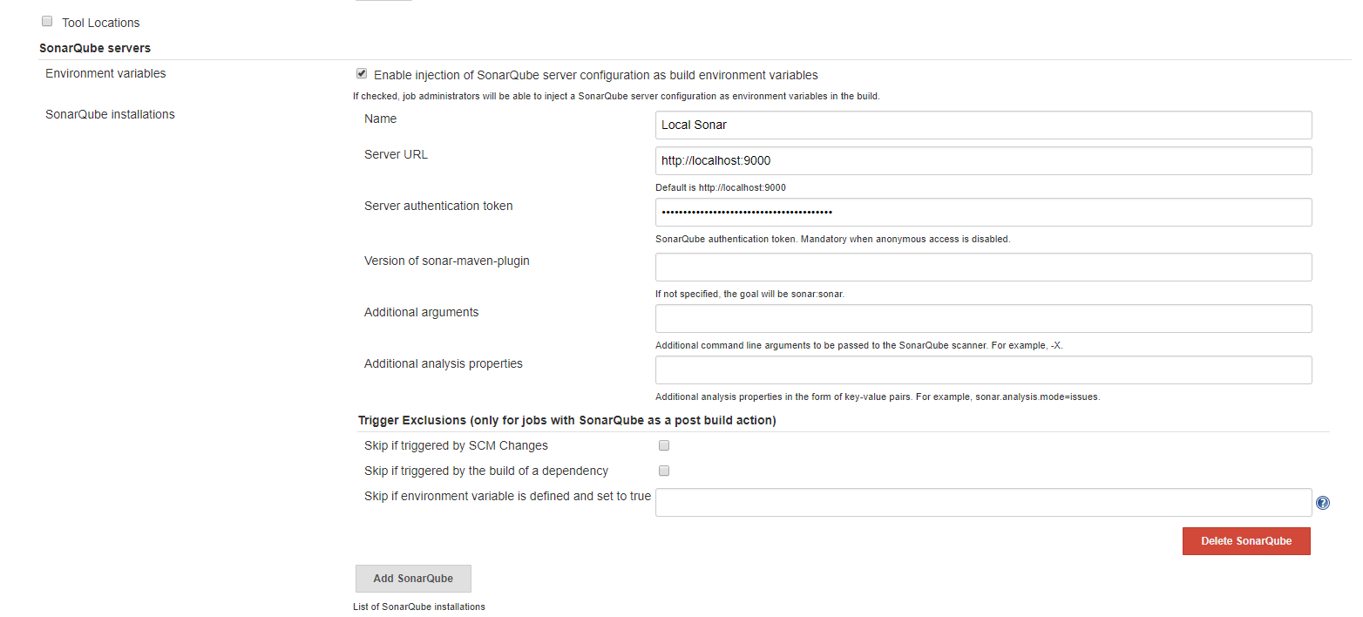

1. Now click on **Save Button.**

**Starting the Sonar Server:**

1. Download SonarQube from the URL: <https://www.sonarqube.org/downloads/>
2. Unzip the downloaded folder
3. In the downloaded folder Go to the following path:

**Sonar > bin > (here depending on your system OS go to appropriate folder) windows-x86-64**

1. Now Run **StartSonar.bat** in case of **windows environment**

In case of **Linux environment** run **Sonar.sh** file

1. Sonar will start as shown below

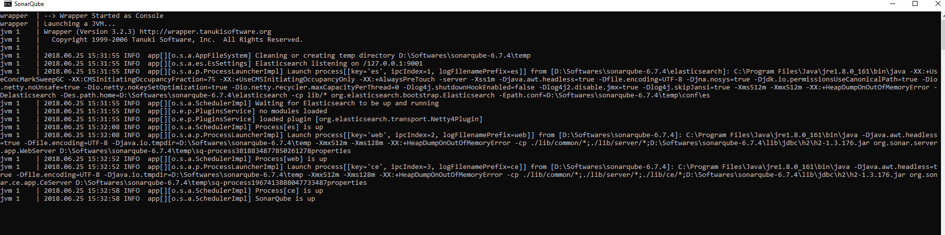

**Code Analysis and Coverage:**

1. In maven **Settings.xml File** under **<profiles>** tag add the following code.

<profile>

<id>sonar</id>

<activation>

<activeByDefault>true</activeByDefault>

</activation>

<properties>

<sonar.host.url>http://localhost:9000</sonar.host.url>

</properties>

</profile>

1. In Project **POM.xml** File add the following code under

<plugin>

<groupId>org.apache.maven.plugins</groupId>

<artifactId>maven-surefire-plugin</artifactId>

<version>2.8.1</version>

</plugin>

<plugin>

<groupId>org.jacoco</groupId>

<artifactId>jacoco-maven-plugin</artifactId>

<version>0.7.9</version>

</plugin>

**Running the Build:**

1. Click on Build now button from the home page present w.r.t the project you want to build.

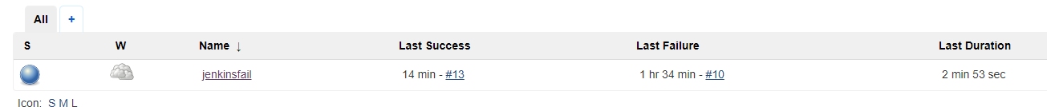

1. Build will run. Click on the Build running.

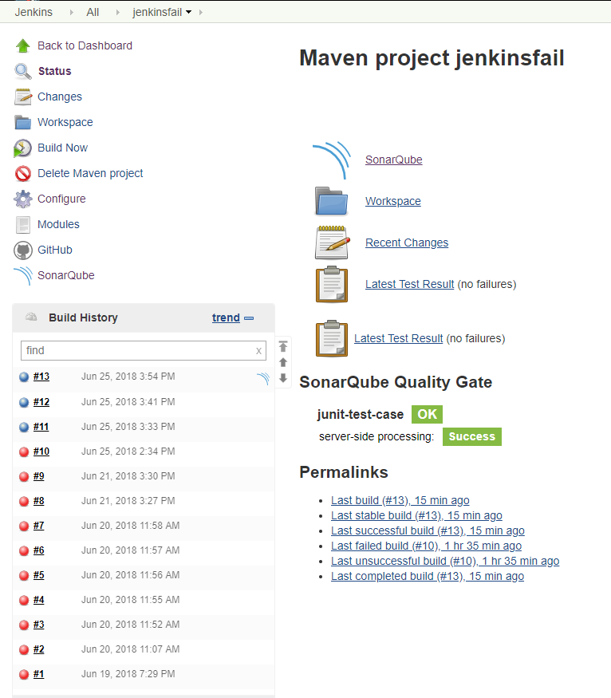

1. Click on **Console Output**

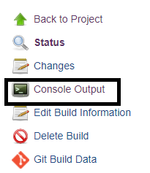

1. Now once its shows Build as Success, it will generate a sonar link w.r.t the project as shown below

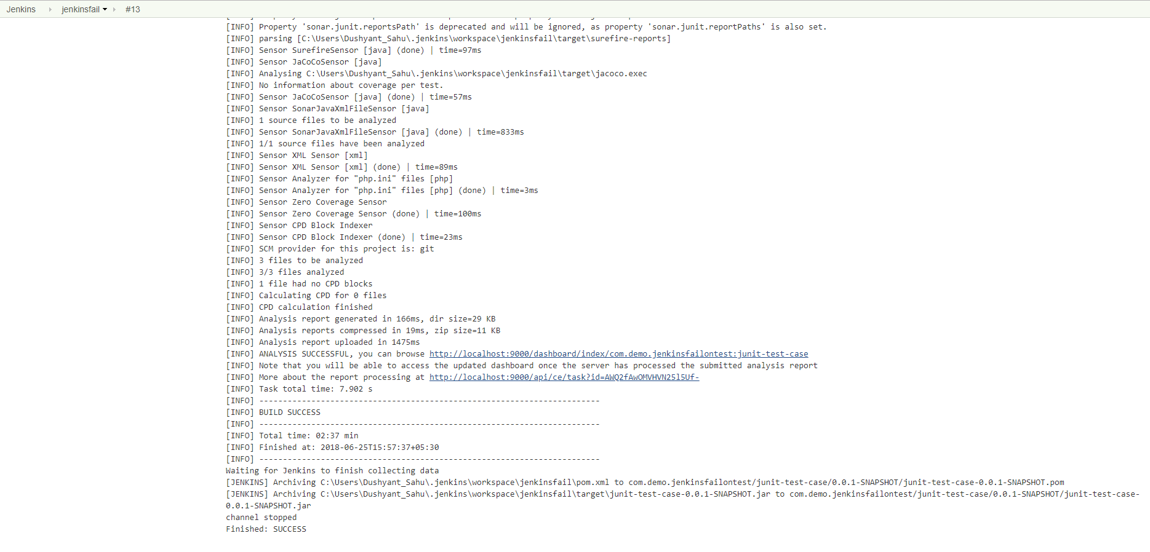

1. Click on the generated link to see the sonar analysis report as shown below.

